Open Api Interface
Version 2021.5

Section I of the FAQs, Preliminary remarks

Preface [Please be sure to read the entire contents of this preface carefully before you begin].
Before you begin, please be sure to read this entire preface carefully!
Before you begin Please make sure you read this entire sequence carefully!
Before you begin Please make sure you read this entire preface carefully!!!!

2. Text

Description of the FAQs◥▬◥▬ | This document gives third-party developers in the App, Web and WeChat domain to implement Gps location services to provide convenience, the domain name (call the url) please provide their own, be sure to follow the document's request parameters to organize the request link, especially pay attention to the request parameters of the case problem.
The process of chronic illnesses◥▬▬▬ | Preparation: Open this document and display the table of contents as a priority.  ● wps software open, please click view - click navigation pane can be.  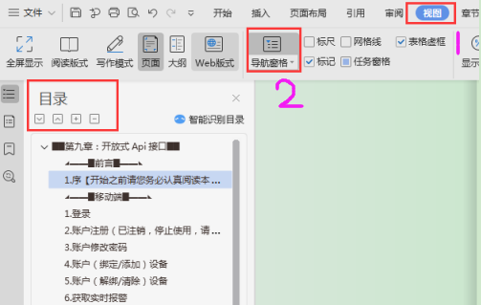  ● Office opens by holding down Ctrl+F. The following image appears, click the circled button.  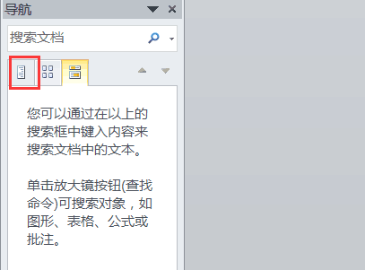  First: Use your account and password to get the mds through the login interface, whether you are logging in with an account (unit user) or a device number.  Second: get the login interface returns two values mds and id (this id and login type consistent, account login is the unit id, device number login is returned to the device id), these two values are very important.  Third: formally enter the call function interface link, with the above two values, you can get a list of units or equipment list and so on a series of operations.  Fourth: However, if you want to use the interface to get the latest position and history track, you must call the interface "get device list" first, because there is a correspondence between macid (device number) and device id.  Fifth: The chart below is the sequence and an interpretation of the 4 sentences above:  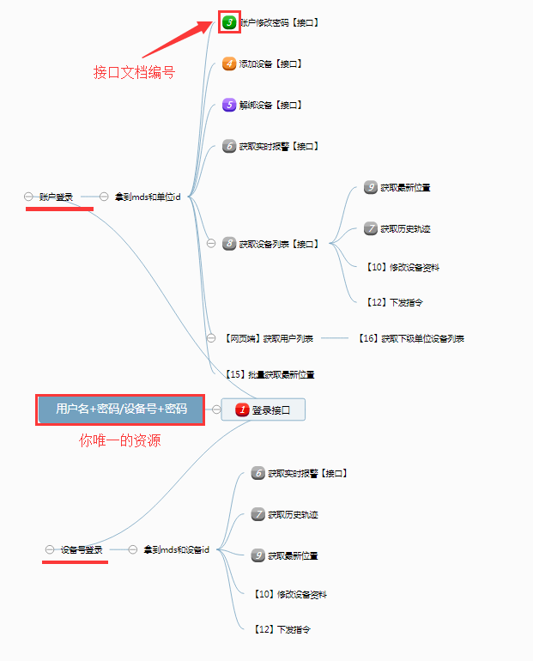
Nomenclature◥ | ●mds: token, about 98% of interface calls must carry this parameter, obtained through the login interface. When the call to the interface returns 403, there is only one meaning that the token expires, the token is valid for 20 minutes, if you keep requesting data, the expiration time is postponed by the last request. It's really expired, just log in again!  ● unit id: user database primary key (database index unique value), is 32-bit length Guid, (unit user) in the call [login] interface can get this value, a series of interfaces related to the logger are involved in this id.  ● Device id: device database primary key (database index unique value), is 32-bit length Guid, (get device list interface or [login] interface (device number type) can get this value), a series of operations about the device are involved.  ● Device number: it is an 8-15 bit string, it is one of the credentials to identify the terminal device, it is very widely used, the interface to get the device list can get this value, the location in the web platform is shown in the following figure:  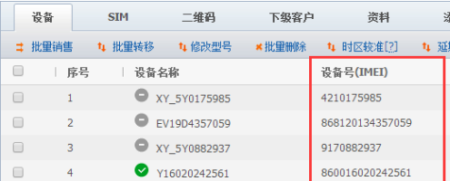  ●utc timestamp: all platforms uniformly use the 13-bit utc timestamp milliseconds, seconds on the basis of *1000, the following figure is the javascript in the web page side of the timestamp to get.  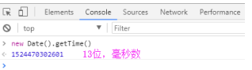  ● Request method: the request method given at the beginning of the form is not fixed, you can choose whether to get or post as needed.
Temporary url | apitest.18gps.net (the following official url is recommended when there are no special requirements)
Official url | api.18gps.net
Type of maps◥ | The full platform involves MapType taking values of the following four types:  GOOGLECN  BAIDU  GAODE  QQ  It represents Google Maps, Baidu Maps, AutoNavi Maps, Tencent Maps.
►▬▬◣报警编号及描述◥▬▬◄
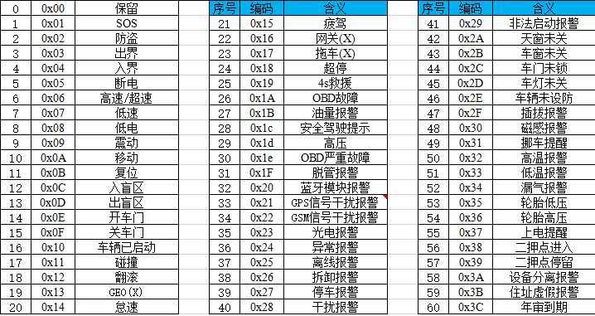
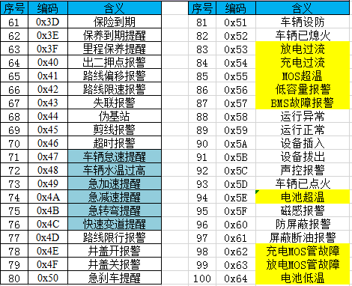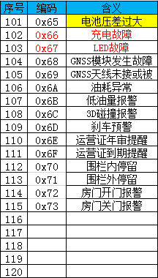
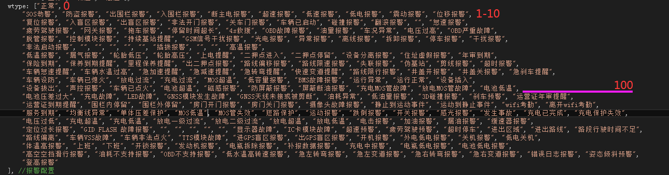

The corresponding table of ►▬▬◣ error codes◥▬▬▬◄
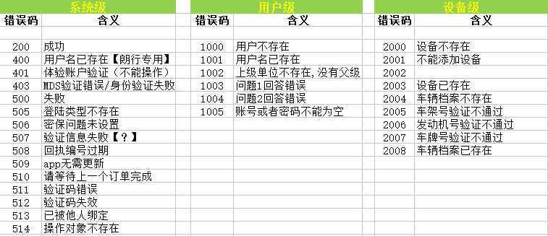
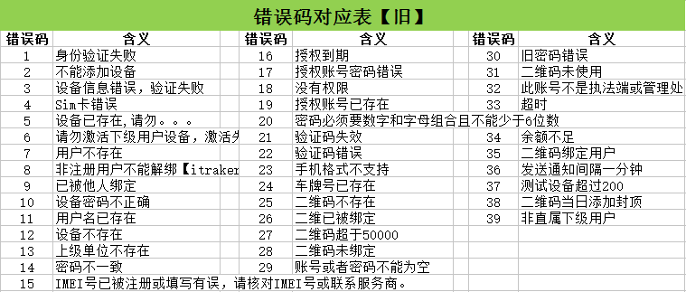

Section II of the FAQs, the mobile terminal

1.Login
interface name  request method  Example of a request | url/GetDateServices.asmx/loginSystem
 | HTTP GET
 | http://apitest.18gps.net/GetDateServices.asmx/loginSystem?LoginName=fangbing&LoginPassword=123456&LoginType=ENTERPRISE&amp ;language=cn&ISMD5=0&timeZone=+08&apply=APP&loginUrl=http://vipapi.18gps.net/
parameters | typology | mandatory field | descriptive
LoginName | String | be | Login Account
LoginPassword | String | be | login password
LoginType | String | be | Login type [Unit user:ENTERPRISE/Equipment login:USER]
language | String | be | Language type [cn,chinese;en,english]
timeZone | Int | be | Time zone [default 8]
apply | String | be | Application Type [Default APP]
ISMD5 | Int | clogged | MD5 validation [default 0 not validated]
loginUrl | String | clogged | http://appzzl.18gps.net/
R&D Remarks
1. [Remarks] This is the first interface that you have access to this document, all the interfaces behind are similar structure, unclear places timely feedback to the project sponsor.
2. [Use] is to get the value of the token, that is, mds (mds can be understood as a symbol of the identity of the logged in person) if in the use of other interfaces to return errorCode = 403, that is, mds expired, you need to re-tune the login interface to get a new mds.
2. [Request] must be filled is to give the value, do not give an error, the default value is also possible; if there is no, it can be filled or not, depending on the specific situation.
3. [Reply] return data to a large extent is the standard json object string, but not absolute, pay attention to see the example to return results prevail. The most common is that there are always people return the id wrong as the device id to get the latest location, in fact, here is the login type is "ENTERPRISE", the return id is the unit id, if the login type is USER, is the device id, please note.

Requested results
Success:
{
"id": "5aa9e28a-80e3-4e29-b2b1-02774724d0", //id of the person who logged in (depending on the type of login, in this case the unit id)
"success": "true", //whether the login was successful or not
"mds": "token user identifier", //token
"LoginType": "ENTERPRISE", //Login Type: Unit User Login
"grade": 4, //account level
"msg": "Login successful", //Error description
"errorCode": 200 //error code
}
Failure:
{
"id": "00000000-0000-0000-0000-0000-000000000000",
"success": "false",
"mds": null,
"LoginType": "ENTERPRISE",
"grade": -2000.
"msg": "User name or password error",
"errorCode": 404
}

2. Account registration (including equipment)
interface name  request method  Example of a request | RegisterUser
 | HTTP GET
 | http://apitest.18gps.net//GetDateServices.asmx/GetDate?method=RegisterUser&macid=xy1610100063&loginName=17150310018& password=123456&repassword=123456
parameters | typology | mandatory field | descriptive
method | String | be | interface name
macid | String | be | Device number (IMEI)
loginName | String | be | user ID
password | String | be | cryptographic
repassword | String | be | Confirm Password
R&D Remarks
You can use this interface if you need such registration in the app or WeChat.

Requested results
The general interface:
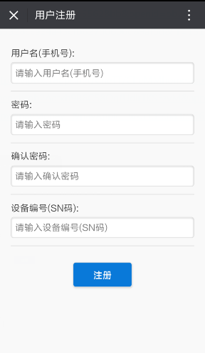

3.Account change password
interface name  request method  Example of a request | modifyEnterprisePwd
 | HTTP GET
 | http://apitest.18gps.net//GetDateServices.asmx/GetDate?method=modifyEnterprisePwd&reg_pass=1234&reg_olbpass=123456&mds =c74c94d2c9da4ec49cdc3f2795b71dc1
parameters | typology | mandatory field | descriptive
method | String | be | interface name
mds | String | be | token
reg_pass | String | be | new password
reg_olbpass | String | be | old password
ISMD5 | Int | clogged | 0 not validated/1 validated
R&D Remarks
- Regardless of whether MD5 authentication is enabled or not, the new password reg_pass must be in plaintext.
- MD5 authentication must pass uppercase values (password encryption requires uppercase ciphertext).

Requested results
Success:
{
"success": "true",
"errorCode": "200",
"errorDescribe": "Modified successfully"
}
Failure:
{
"success": "false",
"errorCode": "500",
"errorDescribe": "Description"
}

4. Account (binding) equipment
interface name  request method  Example of a request | ActiveAndAddDevice
 | HTTP GET
 | http://apitest.18gps.net//GetDateServices.asmx/GetDate?method=ActiveAndAddDevice&login_id=3dfca26777e549338a72e03e1c354d65&amp ;mds=e4495806ce1a4d42a7f6eba2f9d36ef0&FullName=H25685&Macid=011610300002
parameters | typology | mandatory field | descriptive
method | String | be | interface name
mds | String | be | token
login_id | Guid | be | Unit id
Macid | String | be | Device number (IMEI)
Platenumber | String | clogged | license plate number
FullName | String | clogged | Device name (nickname)
R&D Remarks
To add a device to an account, the value of the parameter login_id is taken from the id field in the data returned at login.
Purpose:
Subordinate customers or end users bind devices. Not adding a brand new device directly to the platform.

Process:
10,000 devices were added to the A account.
All subordinates of account A can be used under their own account by tying them to the device number.
Not being an A account subordinate prompts 1, Insufficient Privileges.
Requested results
Success:
{
"success": "true",
"errorCode": "200",
"errorDescribe": "",
"data": [{"user_id": "476f61b2c6c349f3a9fc3e727090cb7a"}]
}
Failure:
{
"success": "false",
"errorCode": "9",//has been bound by someone else
"errorDescribe": "BoundedByOther".
"data": []
}

5. Account (unbundling) equipment
interface name  request method  Example of a request | unbundlingDevice
 | HTTP GET
 | http://apitest.18gps.net//GetDateServices.asmx/GetDate?method=unbundlingDevice&mds=e4495806ce1a4d42a7f6eba2f9d36ef0&macid= 011610300002
parameters | typology | mandatory field | descriptive
method | String | be | interface name
mds | String | be | token
login_id | Guid | be | Unit id
macid | String | be | Device number (IMEI)
R&D Remarks
Functionality is the opposite of the binding interface, unbinding does not mean that the device is completely deleted, but rather it goes back to the account where the device was first added, and can still be retrieved through the binding interface.
Requested results
Success:
{
"success": "true",
"errorCode": "200",
"errorDescribe": "",
"data": []
}

6. Get real-time alarms
interface name  request method  Example of a request | queryLocalAlarmInfoUtc
 | HTTP GET
 | http://apitest.18gps.net//GetDateServices.asmx/GetDate?timestamp=1508228270718&method=queryLocalAlarmInfoUtc&callback= timeWarnOBJ.loadDataCallBack&school_id=754a5a28-8f24-47ff-908f-c363663db852&mds=72311ebde9e94e1292152436303362ff&max_ time=1508103827687&type=custom
parameters | typology | mandatory field | descriptive
method | String | be | interface name
mds | String | be | token
school_id | Guid | be | Unit id/equipment id
type | String | be | Fixed value "custom"
max_time | Long | be | Time of last alarm (Utc timestamp in milliseconds, control acquisition range)
timestamp | Long | clogged | Random number (for refreshing the cache)
callback | String | clogged | callback method name
R&D Remarks
school_id can be one of the two login types.
The maximum number of alarms that can be fetched is 150 for unit logins and 60 for device logins, with data from the cache.
If you want to get the history of alarms, use Section 20.Getting Alarm Details .

How do you achieve real-time access?
1. The key is the max_time field.
2. The first time you access the interface, assign a default value to max_time, for example, 12:00 noon yesterday, then what you get will be the alarm data between max_time (12:00 noon yesterday) and now.
3. If there is data returned (when total is not equal to 0), it means that there is an alarm during this time, compare max_time and send_time when organizing the data, and assign the largest value to max_time, so that max_time is always the time of the last alarm.
4. Set a timer to poll the interface every 10 seconds, as long as the return data is not null, the value of max_time changes, and if it is null, it does not change to realize real-time.
5. If you do not need to use jsonp callback, remove the callback, the return will be a json object.

Requested results
Success:
timeWarnOBJ.loadDataCallBack(
{
"total": 1.
"rows": [
{
"id": "1c20ee64-8eff-43aa-b77c-2a00c57cf3ce",// alarm number (database primary key)
"macid": "864306200010433",// device number
"course": 0,// Directions
"gps_status": "expired today",// description
"gps_time": 1508203827687,// time alarm data was received
"jingdu": 113.853685,// longitude
"weidu": 22.5890067,// latitude
"send_time": 1508203827687,// alarm time
"speed": "0",// speed
"status": 0,// whether to process, 0 means not processed
"type_id": 61,// alarm type
"classifyDescribe": 0,// Secondary classified description, complementary role
"user_id": "75b9aca9-108a-43d5-90da-60095e6c6006",// Device ID (Guid)
"user_name": "GT03Y0010433",// device name
"macname": "GT03Y"// device model number
}
],
"success": true
})

7. Get the history track
interface name  request method  Example of a request | getHistoryMByMUtcNew/getHistoryMByMUtc/
 | HTTP GET
http://apitest.18gps.net//GetDateServices.asmx/GetDate?method=getHistoryMByMUtcNew&mds=457672d6a837446ba3ca7aa9fde8f4c5& playLBS=true&macid=9180144748&mapType=BAIDU&from=1521129600000&to=1521215940000

http://apitest.18gps.net//GetDateServices.asmx/GetDate?method=getHistoryMByMUtc&mds=457672d6a837446ba3ca7aa9fde8f4c5& playLBS=true&userID=5d6fe45c-55cc-4345-a60a-46721eaf0b08&mapType=BAIDU&from=1521129600000&to=1521215940000
parameters | typology | mandatory field | descriptive
method | String | be | interface name
mds | String | be | token
macid | String | be | Device number (IMEI)
mapType | String | be | Map type (BAIDU)
from | Long | be | Utc timestamp milliseconds (start time)
to | Long | be | Utc timestamp milliseconds (end time)
playLBS | Bool | clogged | Whether to acquire base station track points
R&D Remarks
1. from and to the value of the front-end take the following chart, all types of programming environments have conversion methods, search Baidu.
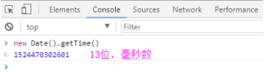
2. The returned Point field is of string type.
3. Can only get 1000 pieces of data, if the return is less than 1000, then it has been taken, if it is equal to 1000, then it means that there are still tracks that have not been taken.
4. Not taken, the maximum time of the first acquisition of 1000 pieces of data as the start time of the second acquisition continue to call this interface until the number of pieces acquired is less than 1000.
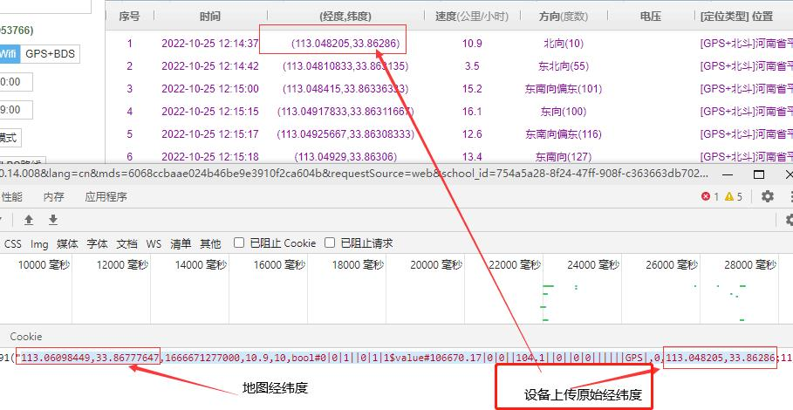

Requested results
Success:
"113.0820431,33.8673257,1513126704000,10.9,37,bool#1|0|1||0|1|1$value#253781.84|0|||||||0|0||||||GPS|,0;113.0821168,33.8673128, 1513126720000,0.2,0,bool#1|0|1|0|1|1|1$value#253781.84|0|||||||0|0||||||GPS|,0;113.0821572,33.8672707,1513126729000,11.4,131,bool#1 |0|1||0|1|1$value#253781.85|0|||||||0|0||||||GPS|,0"
Detailed Description:
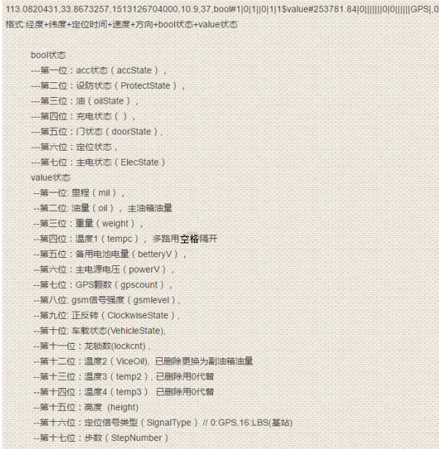
Failure:
""
R&D Remarks:
Someone asked about how to parse the data inside?
- First use the symbol ";" to separate all the data to get the total number of data items, is an array A
- Loop through this array to get A[i];
- Suppose a=A[i]="108.380335, 22.761847, 1557959518000, 38.89, 45, bool#1|0|1||0|1|1$value#10473.23||||100|||||||||||GPS|, 0";
- Separate single entries with bool#, take the first digit after separating, continue | separating, get array of bool values
- Then use value# to separate the entries, take the first digit after separation, and continue to |separate to get an array of value values.
- Note ah, the fourth and fifth should be written separately, remember!!!!

Here's a picture.
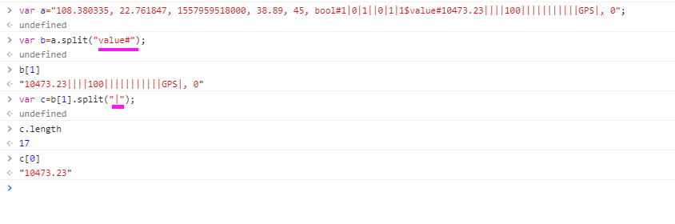

8. Get device list
interface name  request method  Example of a request | getDeviceList
 | HTTP GET
 | http://apitest.18gps.net//GetDateServices.asmx/GetDate?method=getDeviceList&mds=3f8a8c56a7df4be0b7561e44c13fa069
parameters | typology | mandatory field | descriptive
method | String | be | interface name
mds | String | be | token
id | Guid | clogged | Subordinate Unit ID [Alternate]
R&D Remarks
Fetch information about devices that are directly under your account. (Does not include subordinates)
Requested results
Success: offline 0 offline 1 online stationary 2 online traveling
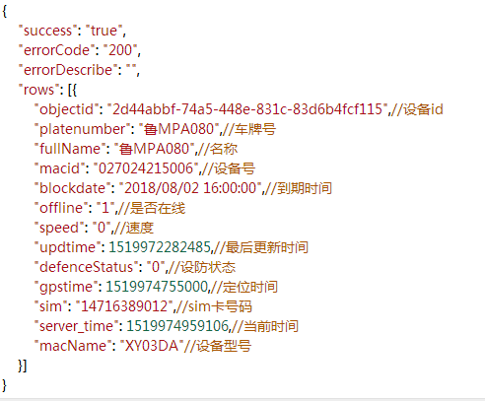

9. Get latest location (single device)
interface name  request method  Example of a request | getUserAndGpsInfoByIDsUtc
 | HTTP GET
http://apitest.18gps.net/GetDateServices.asmx/GetDate?mapType=BAIDU&mds=0e41931ac2654d2e839d29847c385ad8&method= getUserAndGpsInfoByIDsUtcNew
&option=cn&user_id=c0095ae6-db7d-4932-8cb5-5b1531ed3637

Interface name: getUserAndGpsInfoByIDsUtcNew
parameters | typology | mandatory field | descriptive
method | String | be | interface name
mds | String | be | token
mapType | String | be | Map type "BAIDU"
option | String | be | Language "cn"
user_id | Guid | be | Device id
R&D Remarks
How can I tell if I'm online?
Compare the signal time (serial number 7) with the server time (serial number 15), a difference of 25 minutes is offline, less than 25 minutes is online, and a speed of 0 is stationary, but not 0 is traveling.

How do I calculate how long I've been stationary or offline?
Duration = server_time (system time) - datetime (update time)
Offline time = server_time (system time) - heart_time (device heartbeat time)
Note: The calculations are all milliseconds, divided by 1000 is seconds, app development and h5 have the code for conversion, search online.

Not enabled: speed equal to -9 and offline time (server_time - heart_time) > 25 minutes.
Expired judgment: server_time (system time) - expire_date (expiration time, serial number 17)

Requested results
Success:
The data inside the key belongs to the explanatory, records array inside each array of each value is really useful to you, such as status corresponds to the "status [as status]", generally used in this way: records[0][ status]. Also, an empty records array means that the account has no devices.
{
"success": "true",
"errorCode": "200",
"errorDescribe": "",
"data": [

{
"key": { //This key is the detailed note for the following records group
"sys_time": 0, //device positioning time
"user_name": 1, //device name
"jingdu": 2, //longitude (gps location) // Longitude (gps location)
"weidu": 3. //latitude (gps location)
"ljingdu": 4, //longitude of the base station //base station longitude (base station or wifi localization use latitude and longitude here)
"lweidu": 5. //base station latitude (base station or wifi location use latitude and longitude here)
"datetime": 6. //datetime of data update (time received by the server)
"heart_time": 7, //device heartbeat time (signal time)
"su": 8. //speed
"status": 9. //Status group [status in the following table].
"hangxiang": 10, //direction
"sim_id": 11, //device number
"user_id": 12, //device id
"sale_type": 13, //Sale type - no use
"iconType": 14. //Icon
"server_time": 15, // System time (current time)
"product_type": 16, //device type
"expire_date": 17, //Expiration date
"group_id": 18, // Monitor group ID
"statenumber": 19. //Information group [as in table status].
"electric": 20.
"describe": 21. // device description information (usually holds some operational parameters for device uploads)
"sim": 22. //sim card
"precision": 23 //precision error (Lbs/WiFi) when the value is 10 means gps positioning, no precision [invalid].
isFollow":24, "IsFollowDevice
plateNumber":25, "License plate number
auth":26, "Permissions
authList":27, "Permission List
deptname":28 "Unit name
(Added 202211/11)
Actual value taken, one more bit here, attention or not, authorization or not, no purpose
}, }
"records": [
[
1505987223000, //device positioning time (utc timestamp)
"Device Name".
113.8272056.
22.6993799.
113.8272056.
22.6993799.
1505987173965,
1506325381478.
"0".
"1010000".
0,
"Device number".
"a12e71f7a9b248df91fcbc65cbd9649".
1.
"01".
1506399055758,
"T3".
1516233600000.
"0".
"2435.99,0,0,0,0,0,0,0,0,0,0,0,0".
0,
"",
"",
10
]
],
"groups": []
}
]
}
status (description): eight consecutive characters
--- First position: acc state (accState 1 on 0 off).
--- Second bit: the state of the device's own arming (ProtectState 1 arming 0 disarming).
--- Third position: oil and electricity (oilState 1 on 0 off).
--- Fourth digit: state of charge ().
--- Fifth position: door status (1 open, 0 closed),
--- Sixth position: localization status (1 localized 0 not localized) [no significance]
--- Seventh position: main power state (ElecState)
---- Eighth position: platform defense status (defend) [no significance]
--- 9th position: platform stealth status (gpsOnOff) (1 for stealth)
Statenumber (description): sixteen consecutive comma-separated characters
--- First place: miles (mil).
---second place: volume of oil.
---Third place: weight.
--- Fourth position: temperature 1 (tempc).
--- Fifth digit: standby battery power (betteryV), power is expressed in two forms: 1 is a percentage 2 is V (volts) Getting power greater than 100, -100 go to V units, less than 100 by percentage
--- Sixth position: mains voltage (powerV), unit: V
--- Seventh place: GPS count (gpscount).
--- Eighth position: gsm signal strength (gsmlevel),
--- 9th position: ClockwiseState.
---Tenth position: VehicleState.
--- Eleventh: lockcnt, the number of dragon locks.
--- Twelfth position: Temperature2 (temp1),
--- Thirteenth position: Temperature 3 (temp2),
--- Fourteenth position: Temperature 4 (temp3)
---Fifteenth position: height
--- Sixteenth position: positioning signal type (SignalType) 0: Beidou GPS 1: Wifi positioning 16: base station positioning
--- Seventeenth position: StepNumber
--- 18th position: frame number

R&D Supplement:
{"key":{"sys_time":0, "user_name":1, "jingdu":2, "weidu":3, "ljingdu":4, "lweidu":5, "datetime":6, "heart_time":7, "su":8, "status":9,"" hangxiang":10, "sim_id":11, "user_id":12, "sale_type":13, "iconType":14, "server_time":15, "product_type":16, "expire_date":17, "group_id" :18, "statenumber":19, "electric":20, "describe":21, "sim":22, "precision":23, "isFollow":24}, "records":[[1557712988, "#59",121.527837. 31.100259,121.527837,31.100259,1557712988000,1557713134721, "0", "10000010",124.0, "8629640236329", "fdd70e9ebc6c4559aca661e49e",0, "22 ",1557713139056,"GS05B",2204150400000,"0","4.59,0,0,,6,0,12,4,0,0,0,0,0,0,0,0,",6.0,"ICCID:89860412101","",10,"0"]],"groups":[]}

The blue parts are useful, the rest are comments
[ //corresponds to the note above
1557712988,
"59".
121.527837.
31.100259.
121.527837.
31.100259.
1557712988000,
1557713134721,
"0".
"10000010".
124.0.
"8629640236329".
"fdd70e9ebc6c4559aca661e49e".
0,
"22".
1557713139056,
"GS05B".
2204150400000.
"0".
"4.59,0,0,,6,0,12,4,0,0,0,0,0,0,0,0,0,".
6.0.
"iccid:89860412101".
"",
10, //When the value is 10 it means gps positioning without (base station/wifi) accuracy;
"0" // whether to focus on [no use]
]

Note that there is a logic: first determine whether the expiration, and then determine whether the positioning, and then determine the kind of positioning, and then finally organize the corresponding display effect.

10. Modify equipment information
interface name  request method  Example of a request | SetGpsUserFullNameAndPlateNumber
 | HTTP GET
 | url/DataService.ashx/GetDate?method=SetGpsUserFullNameAndPlateNumber&macid=DeviceNumber&fullName=DeviceName&plateNumber=plate number&mds= (Login interface to get)
parameters | typology | mandatory field | descriptive
method | String | be | interface name
mds | String | be | token
macid | String | be | Device number (IMEI)
fullName | String | be | Equipment Name
plateNumber | String | be | license plate number
LinkName | String | clogged | associates
LinkTel | String | clogged | contact number
sim | String | clogged | Device sim card number
R&D Remarks
Note that the last three are not required content, there is a need to fill in for modification.
Requested results
Success:
{
"data": [].
"success": "true",
"errorCode": "200",
"errorDescribe": "Modified successfully"
}

11. Logging out
interface name  request method  Example of a request | LoginOut
 | HTTP GET
 | http://apitest.18gps.net//GetDateServices.asmx/GetDate?method=LoginOut&mds= (accessed through the login interface)
parameters | typology | mandatory field | descriptive
method | String | be | interface name
mds | String | be | token
R&D Remarks
Role:
Clear the mds cache to keep your information safe;
Clear the pushId for app push (when push function is included).

Requested results
Success:
{
"data": [].
"success": "true",
"errorCode": "200",
"errorDescribe": "Modified successfully"
}

12. Issuance of instructions
interface name  request method  Example of a request | SendCommands
 | HTTP GET
 | http://apitest.18gps.net//GetDateServices.asmx/GetDate?method=SendCommands&macid=00005581D8F3&cmd=GETVERSION&param=& amp;pwd=&sendTime=&mds=6efb1fda32bb4416a7a29e54a1b045d1
parameters | typology | mandatory field | descriptive
method | String | be | interface name
macid | String | be | Device number (IMEI)
mds | String | be | token
cmd | String | be | command name
param | String | clogged | Parameters issued, separated by English commas
pwd | String | clogged | Device Password
sendTime | DateTime | clogged | Setting the sending time
R&D Remarks
When the command is successfully issued, the "CmdNo" command receipt number is returned.
var backMess = { flowID: 'Flow ID', SEND_SUCCESS: 'Operation successful', SEND_FAIL: 'Operation failed failed failed', PWD_ERROR: 'Password error', NOT_CUSTOMER: 'Customer does not exist', USER_LEAVE: 'Current device is offline, scheduled to be executed when online. .' , 'Not Online': 'Current device is offline, scheduled for execution after going online.' , 'PERMISSIONS': 'Experience account, can't send commands', Nonsupport: 'Command is not supported, please contact join support', SEND_OK: 'Command sent successfully', Fail: 'Command sent failed', DeviceNot: 'Device doesn't exist', Cmd_ExceedLength: 'Warning: queue is full! Please go to the [Command-Download Record] page to check!' };

Arming cmd: SAFEON (general, special instructions may not be this value)
Disarm cmd: SAFEOFF (general, special commands may not be this value)
Passthrough cmd: PASSTHROUGH (parameter "0,5554" means text send 5554; "1,5554" means hexadecimal send 0x55 0x54)

Requested results
Success:
{
"success": "true",
"errorCode": "200",
"errorDescribe": "",
"data": [{
"CmdNo": "e2b6b72c-27a3-4b86-9da0-477aa43a3518",//Return receipt number
"ReturnMsg": "USER_LEAVE"
}]
}

13. Querying of the results of orders issued
interface name  request method  Example of a request | GetCommandResults
 | HTTP GET
 | http://apitest.18gps.net//GetDateServices.asmx/GetDate?method=GetCommandResults&macid=00005581D8F3&cmdNo=e2b6b72c-27a3- 4b86-9da0-477aa43a3518&mds=6efb1fda32bb4416a7a29e54a1b045d1
parameters | typology | mandatory field | descriptive
method | String | be | interface name
macid | String | be | Device number (IMEI)
mds | String | be | token
cmdNo | String | be | Reply No.
R&D Remarks
None.
Requested results
Success:
------

14. Request for latitude and longitude
interface name  request method  Example of a request | ---
 | HTTP GET
 | http://poi.18gps.net/POI?lat=22.36&lon=114.256&map=BAIDU
parameters | typology | mandatory field | descriptive
lat | Double | be | longitude
lon | Double | be | longitudes
map | String | be | Map Type
R&D Remarks
See preface for map types.
Requested results
Success:
26B2/F., Lane 7, Ho Chung Village, Sai Kung District, HKSAR. 197 meters at Luk Nim Yat Wee Sun Tan (Northwest)

15.Batch get the latest location
interface name  request method  Example of a request | getDeviceListByCustomId
 | HTTP GET
 | http://apitest.18gps.net//GetDateServices.asmx/GetDate?method=getDeviceListByCustomId&mds=a1324221c41d44a08f93445b1bec63dd&amp ;id=e9c939f1-9c06-4312-b295-47f0162b4176&mapType=BAIDU
parameters | typology | mandatory field | descriptive
method | String | be | interface name
id | Guid | be | Unit ID
mds | String | be | token
mapType | String | be | Map Type
R&D Remarks
Return Data Remarks and Get Latest Location (Single Device) are consistent.
Map type fill in the blank to get WGS84 coordinates latitude and longitude
Requested results
Success: {"success": "true", "errorCode": "200", "errorDescribe":"", "data":[{"key":{"sys_time":0, "user_name":1, "jingdu":2, "weidu":3, "ljingdu ":4, "lweidu":5, "datetime":6, "heart_time":7, "su":8, "status":9, "hangxiang":10, "sim_id":11, "user_id":12, "sale_type":13, "iconType":14, "server_time":15, "product_type":16, "expire_date":17, "group_id":18, "statenumber":19, "electric":20, "describe":21, "sim":22, "precision ":23, "isFollow":24}, "records":[[1444202949000, "skycard",114.046648,22.652224,114.046648,22.652224,1444202951657,1444202951657, "5"," 00000100",319.0, "383715011929452", "1fe02b6045a4477aae90e66a7c2218de",0, "24",1547696829997, "GT003",2565648000000, "0", "0.42,0,0,,0,6 ,0,86,0,0,0,0,0,0,0,0,0",0.0,"","",10, "0"],[1538011845000, "SC2082204818",116.158823,34.279542,116.158823,34.279542,1538012061443,. 1538012061443, "57.7", "10100110",22.0, "993182204818", "8d54f75b3469471face04d88f57cda03",0, "01",1547696829997, "SC20",1553529600000," 0", "0,0,0,0,14.39,11,22,0,1,0,0,0,0,0,0,0,0,0,0,0,0,0"","",10, "0""]], "groups":[], "followCount":0, "deviceCount":23}]]}

16. Get the list of equipment of subordinate units
interface name  request method  Example of a request | getDeviceListByCustomId
 | HTTP GET
 | http://apitest.18gps.net//GetDateServices.asmx/GetDate?method=getDeviceListByCustomId&mds=9309428153234490931b3923d170cd40&amp ;id=334f2e92-787d-45e8-bf5c-3b500a8c787d
parameters | typology | mandatory field | descriptive
method | String | be | interface name
mds | String | be | token
id | Guid | be | Subordinate Unit ID
mapType | String | clogged | Map type (default Baidu "BAIDU")
R&D Remarks
Takes a list of devices in the subordinate unit.
Requested results
Success:
{
"success": "true",
"errorCode": "200",
"errorDescribe": "",
"data": [{
"key": { // see the latest positional single (section II, interface 9) for more details
"sys_time": 0,
"user_name": 1,
"jingdu": 2.
"weidu": 3.
"ljingdu": 4.
"lweidu": 5.
"datetime": 6.
"heart_time": 7,
"su": 8.
"status": 9.
"hangxiang": 10.
"sim_id": 11,
"user_id": 12,
"sale_type": 13,
"iconType": 14.
"server_time": 15,
"product_type": 16,
"expire_date": 17,
"group_id": 18,
"statenumber": 19.
"electric": 20.
"describe": 21.
"sim": 22.
"precision": 23.
"isFollow": 24
}, }
"records": [
[1482596907000, "601603080377", 114.231935, 22.667007, 114.231935, 22.667007, 1482591004402, 1482596908894, "0", "00000100", 134.0, " 601603080377", "2f45ed3a309744c5b9da11cc5bd3d5dd", 0, "22", 1551926835558, "DXMKT", 2141959763770, "1830a1e7cf8a4790b10e3bab2e7c2406", " 813312.57,0,0,,0,0,5,26,0,0,0,0,0,0,0,0,", 0.0, "", "1234458373", 10, "0"],
[1511853204362, "902b75072918", 114.223921, 22.665438, 114.223921, 22.665438, 1511853204362, 1511853767987, "0", "00000000", 0.0, " 391517075072918", "6a33f9dc7418430ba5388dba4cdc9f33", 0, "22", 1551926835558, "902B", 1544515200000, "0", "0,0,0,,6,0,0,0,100,0,0,0,0,0,0. 16,", 6.0, "", "", "", 550, "0"]
[0, "dxmkt7908511", 0.0, 0.0, 0.0, 0.0, 0, 0, "-9", "00000000", 0.0, "867273027908511", "559d5b39f46c4790b729d2a86f5bef31", 0, "01". 1551926835558, "dxmkt", 1542240000000, "0", "0,0,0,0,0,0,0,0,0,0,0,0,0,0,0,0,0,0,0,0,0,0,0,0,0,0,0,0,0,0,0,0,0,0,0,0,0,0,0,0,0,0,0,0,0,0,0,0,0,0,0,0,0,0,0,0,0,0,0,0, "0,0,0,0,0,0,0"]
],
"groups": [].
"followCount": 0, //number of followers
"deviceCount": 3 //number of devices
}]
}

17. Binding device interface [Alternate]
interface name  request method  Example of a request | MoveDevice
 | HTTP GET
 | http://apitest.18gps.net//GetDateServices.asmx/GetDate?method=MoveDevice&mds=9309428153234490931b3923d170cd40&id=334f2e92- 787d-45e8-bf5c-3b500a8c787d&macid=027028656666
parameters | typology | mandatory field | descriptive
method | String | be | interface name
mds | String | be | token
id | Guid | be | Unit ID (write your own)
macid | String | be | device number
R&D Remarks
When you have already registered an account and need to re-add another device to your account.
Requested results
Success:

18. Set up alarm filtering [common for device login and account login]
interface name  request method  Example of a request | setFilterAlarmInfo
 | HTTP GET
 | http://apitest.18gps.net//GetDataService.aspx?method=setFilterAlarmInfo&custid=754a5a28-8f24-47ff-908f-c363663db702&mds= 314dc945b0ea498b81b6de21f47f178e&alarmType=,0,3,7,
parameters | typology | mandatory field | descriptive
method | String | be | interface name
mds | String | be | token
custid | Guid | be | Unit ID (Login ID)
alarmType | String | be | Filtered alarm types, comma-separated
R&D Remarks
The default check box is the item that needs to be alarmed, you need to uncheck the box if you don't want to report this type of alarm.
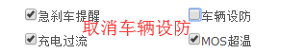
Requested results
Success:
{
success: "true",
msg: 1,
filterObj: ",0,3,7,"} // Filtered alarm type

19. Get filter alarm number
interface name  request method  Example of a request | GetPushAlarmSwitch
 | HTTP GET
 | http://apitest.18gps.net//GetDataService.aspx?method=GetPushAlarmSwitch&mds=314dc945b0ea498b81b6de21f47f178e
parameters | typology | mandatory field | descriptive
method | String | be | interface name
mds | String | be | token
R&D Remarks
Queries the number of the alarm type for which filtering is set.
Requested results
Success:
{
success: "true",
errorCode: "200",
errorDescribe: "",
data: [
[
0,
3.
7
]
]}

20. Get alarm details
interface name  request method  Example of a request | alarmOperation
 | HTTP GET
 | http://apitest.18gps.net//GetDataService.aspx?method=alarmOperation&mds=314dc945b0ea498b81b6de21f47f178e&alarmType=1,2,3,4 ,6,7,8,9,10,11,14,38&enterprise_id=e0329898-4eaa-4612-9f69-00986998d89b&userid=72b92fe0-34ca-483b-b0f9-27e4c7ee3d92& beginTime=1587916800000&endTime=1587951883000
parameters | typology | mandatory field | descriptive
method | String | be | interface name
mds | String | be | token
alarmType | String | be | Alarm Type
enterprise_id | Guid | be | Unit ID (Login ID)
userid | Guid | be | Device ID
beginTime | Long | be | Utc timestamp milliseconds (start time)
endTime | Long | be | Utc timestamp milliseconds (end time)
R&D Remarks
See interface 6 for remarks on return results.
Requested results
Success: {
success: "true",
errorCode: "200",
errorDescribe: "",
data: [
{
id: "efe0fb98-7e86-4a94-bdab-642ae07898cc",
fullname: "Wan A (pressurized vehicle)".
classify: 38.
lon: 117.203048,
lat: 31.926648,
addtime: "2020/04/27 08:31:57",
ptime: "2020/04/27 08:31:44",
status: 0,
speed: 0,
macid: "09103****855",
userid: "72b92fe0-34ca-483b-b0f9-27e4c7ee3992",
macname: "JT808".
NumberId: 3,
Notea: ""
}
]}

21. Device change password
interface name  request method  Example of a request | modifyUserPwd
 | HTTP GET
parameters | typology | mandatory field | descriptive
method | String | be | interface name
mds | String | be | token
macid | String | be | device number
pwd | Guid | be | new password
oldPwd | Guid | be | old password
R&D Remarks
None.
Requested results
Success: {
success: "true",
errorCode: "200",
errorDescribe: "",
data: []
}

22. Send command history
interface name  request method  Example of a request | GetSendCmdList
 | HTTP GET
 | http://api.18gps.net//GetDataService.aspx?method=GetSendCmdList&mds=a544e41669d6455f84b862f666eaffdd&macid=027045307931& amp;count=&_t=1614219663391
parameters | typology | mandatory field | descriptive
method | String | be | interface name
mds | String | be | token
macid | String | be | device number
count | int | clogged | item count (of a consignment etc)
R&D Remarks
None.
Requested results
Success:
{
"success": "true",
"errorCode": "200",
"errorDescribe": "",
"data": [{
"Describe": "GETVERSION",//command word (command type) requires dictionary conversion
"Param": "",//content of instruction
"IsOK": "Null",//status
"Msg":"",// response message
"SendTime": 1614219644177,//send time
"AddTime": 1614219644192,//add time
"ExtData": {
"source": "web:web"//source
}
}]
}

23. Clearing instructions
interface name  request method  Example of a request | ClearCmdList
 | HTTP GET
 | http://api.18gps.net//GetDataService.aspx?method=ClearCmdList&mds=a544e41669d6455f84b862f666eaffdd&macid=027045307931
parameters | typology | mandatory field | descriptive
method | String | be | interface name
mds | String | be | token
macid | String | be | device number
R&D Remarks
Clearing all command records with one click consists of two things:
1. Clearing the sending history (commands successfully cleaned up)
2. Clear the commands that are queuing (cancel sending if the command was unsuccessful or queued).

Requested results
Success: {
success: "true",
errorCode: "200",
errorDescribe: "",
data: []
}

24. Acquiring Dwell Points
interface name  request method  Example of a request | StayDetail
 | HTTP GET
 | http://api.18gps.net/GetDataService.aspx?method=StayDetail&mds=4be0dc807a164c54affba098fe29ebd4&beginTime=1621227915000& amp;endTime=1621231515000&userid=badda545-a4c7-459f-9600-b4729abaeee3&mapType=GAODE
parameters | typology | mandatory field | descriptive
method | String | be | interface name
mds | String | be | token
beginTime | Long | be | Utc timestamp milliseconds (start time)
endTime | Long | be | Utc timestamp milliseconds (end time)
userid | Guid | be | Device id
mapType | String | be | Map Type
R&D Remarks
None.

Requested results
Success:
[
{
"id": 1, //serial number
"fullName": "test-specific",//name
"beginDate": "2021/5/17 12:40:58",
"endDate": "2021/5/17 13:58:40",
"lon": 103.77622606.
"lat": 35.98225666.
"stopCar": "1Hour17Minute42second" //stop time
}
]

Recordings Related to FAQs

1. Access to multimedia records (real time)
interface name  request method  Example of a request | GetMultimediaRecords
 | HTTP GET
 | http://api.18gps.net//GetDataService.aspx?method=GetMultimediaRecords&mds=4708977a492c472288b178ef5ca7f977&target= 6020036221&userId=e0329898-4eaa-4612-9f69-00986998d89b&maxTime=0
parameters | typology | mandatory field | descriptive
method | String | be | interface name
mds | String | be | token
target | String | be | device number
userId | Guid | be | Login ID (ID returned by the login interface)
maxTime | Long | be | Maximum time (Utc timestamp milliseconds)
R&D Remarks
If maxTime is 0, the records obtained are the 50 records closest to the present time.
If maxTime is a specific time, then all records between this point in time and the current time are fetched.

Return data:
Id message number
UserId Account ID
Target device number or user ID or channel ID
Content
FileName
Url file address
InfoType message type [0:voice, 1:video, 2:picture, 3:text]
IsUser if user sends, 0 for device uploads
Addtime to add time

Requested results
Success: {
success: "true",
errorCode: "200",
errorDescribe: "",
data: []
}

2. Get voice history (paging)
interface name  request method  Example of a request | GetVoiceHistory
 | HTTP GET
 | http://api.18gps.net//GetDataService.aspx?method=GetVoiceHistory&mds=4708977a492c472288b178ef5ca7f977&macid=6020036221&amp ;loingId=3975226d-d106-47c1-8cc5-17ebc42818bb&minTime=0&count=10
parameters | typology | mandatory field | descriptive
method | String | be | interface name
mds | String | be | token
macid | String | be | device number
loingId | Guid | be | Login ID (ID returned by the login interface)
minTime | Guid | be | Minimum time (Utc timestamp milliseconds)
count | Int | clogged | Number of articles (default 20)
R&D Remarks
Take macid device, minTime after this point in time, count bar data.

Return data:
Id message number
UserId Account ID
Target device number or user ID or channel ID
Content
FileName
Url file address
InfoType message type [0:voice, 1:video, 2:picture, 3:text]
IsUser if user sends, 0 for device uploads
Addtime to add time
Requested results
Success: {
success: "true",
errorCode: "200",
errorDescribe: "",
data: []
}

3. Delete recordings (supports multiple)
interface name  request method  Example of a request | DeleteSingleVoice
 | HTTP GET
 | http://api.18gps.net//GetDataService.aspx?method=DeleteSingleVoice&mds=4708977a492c472288b178ef5ca7f977&ids=c0095ae6-db7d- 4932-8cb5-5b1531ed3637,c0095ae6-db7d-4932-8cb5-5b1531ed3638&loingId=3975226d-d106-47c1-8cc5-17ebc42818bb
parameters | typology | mandatory field | descriptive
method | String | be | interface name
mds | String | be | token
ids | String | be | Message number, recording number, Guid format, splice with "," if more than one
loingId | Guid | be | Login ID (ID returned by the login interface)
R&D Remarks
Remember the data format for getting records, the first Id field (Guid format) can be used for deletion, and for bulk deletion, just separate them with English commas.
Requested results
Success: {
success: "true",
errorCode: "200",
errorDescribe: "",
data: []
}

The CFEN of the FAQs on Round Fences
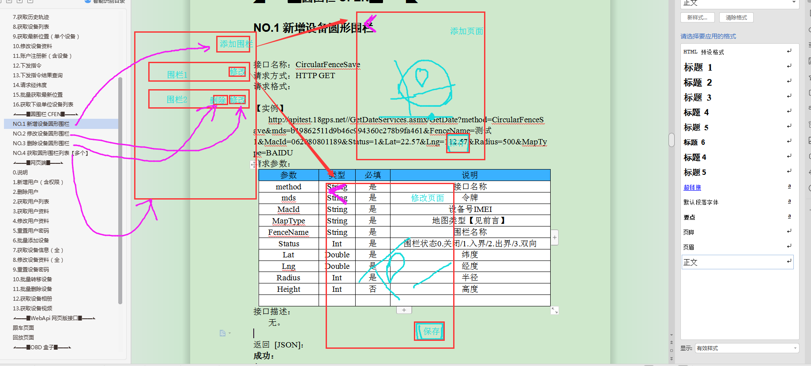

NO.1 Additional equipment circular fence

Interface name: CircularFenceSave
Request method: HTTP GET
Request Format:

[Example]
http://apitest.18gps.net//GetDateServices.asmx/GetDate?method=CircularFenceSave&mds=b19862511d9b46c994360c278b9fa461& FenceName=Test1&MacId=062080801189&Status=1&Lat=22.57&Lng=112.57&Radius=500&MapType=BAIDU
Request Parameters:
parameters | typology | mandatory field | instructions
method | String | be | interface name
mds | String | be | token
MacId | String | be | Device number IMEI
MapType | String | be | Type of map [see preamble]
FenceName | String | be | Fence name
Status | Int | be | Fence status 0. closed / 1. inbound / 2. outbound / 3. bidirectional
Lat | Double | be | longitude
Lng | Double | be | longitudes
Radius | Int | be | radius
Height | Int | clogged | high degree
Interface Description:
None.

Returns [JSON]:
Success:
{
"success": "true",
"errorCode": "200",
"errorDescribe": "",
"data": []
}
Failure:
{

}

NO.2 Modification of equipment circular fences
Interface name: CircularFenceModify
Request method: HTTP GET
Request Format:

[Example]
http://apitest.18gps.net//GetDateServices.asmx/GetDate?method=CircularFenceModify&mds=b19862511d9b46c994360c278b9fa461& FenceName=My3 was modified&MacId=865609163017108&Status=0&Lat=22.57&Lng=112.57&Radius=1200&MapType=BAIDU&Id= 9bf3165f-616b-45f9-8c56-b5210145893c

Request Parameters:
parameters | typology | mandatory field | clarification
method | String | be | interface name
mds | String | be | token
MapType | String | be | Type of map [see preamble]
FenceName | String | be | Fence name
Status | Int | be | Fence status 0. closed / 1. inbound / 2. outbound / 3. bidirectional
Lat | Double | be | longitude
Lng | Double | be | longitudes
Radius | Int | be | radius
Height | Int | clogged | high degree
Id | Guid | be | Fence Id
Interface Description:
None.

Returns [JSON]:
Success:
{
}
Failure:
{
}

NO.3 Deleting the device circular fence
Interface name: CircularFenceDelete
Request method: HTTP GET
Request Format:

[Example]
http://apitest.18gps.net//GetDateServices.asmx/GetDate?method=CircularFenceDelete&mds=b19862511d9b46c994360c278b9fa461& MacId=062080801189&Id=4147d849-dbb6-4fd2-833d-6d2f5ffa08a4
Request Parameters:
parameters | typology | mandatory field | clarification
method | String | be | interface name
mds | String | be | token
MacId | String | be | Device number IMEI
Id | Guid | be | Fence Id
Interface Description:
None.

Returns [JSON]:
Success:
{
}
Failure:
{
}

NO.4 Get a list of circular fences [multiple]
Interface name: CircularFenceGetList
Request method: HTTP GET
Request Format:

[Example]
http://apitest.18gps.net//GetDateServices.asmx/GetDate?method=CircularFenceGetList&mds=b19862511d9b46c994360c278b9fa461& MacId=062080801189&MapType=BAIDU
Request Parameters:
parameters | typology | mandatory field | clarification
method | String | be | interface name
mds | String | be | token
MacId | String | be | Device number IMEI
MapType | String | be | Type of map [see preamble]
Interface Description:
None.

Returns [JSON]:
Success:
{
"success": "true",
"errorCode": "200",
"errorDescribe": "",
"data": [{
"Id": "935bd0f5-c123-485b-b963-afd9f9ada48c", //fence id
"UserId": "00000000-0000-0000-0000-000000000000", //暂无用途
"MacId": "062080801189", //device number
"FenceName": "Test 2", //fence name
"Status": 1,//fence status 0.off/1.inbound alarm/2.outbound alarm/3.two-way
"Lat": 22.566695, //latitude
"Lng": 112.558606, //longitude
"Radius": 800, //radius
"Height": 0, //Height (3-dimensional fence, no use for now)
"MapType": null //map type, when null, represents the original coordinates of the map
}, {
"Id": "0c0ae4ff-f662-4fb1-adfb-70c9be96231d",
"UserId": "00000000-0000-0000-0000-0000-0000-0000-0000-0000-0000-0000-0000-0000-0000-0000-0000-0000-0000-0000",
"MacId": "062080801189".
"FenceName": "Test 3".
"Status": 1,
"Lat": 22.566695.
"Lng": 112.558606.
"Radius": 1000.
"Height": 0,
"MapType": null
}]
}

Failure:
{
}

Authorization Functions of the FAQs

NO.5 Add Device Function Authorization
interface name  request method  Example of a request | EmpowerAdd
 | HTTP GET
 | http://api.18gps.net//GetDateServices.asmx/GetDate?method=EmpowerAdd&Macid=868120167290847&Authorized=13009400093&mds= 3aa6da273ae8402a9291fe3ab1966512&StartTime=1561685418156&EndTime=1561785418156&FunctionList=1,2
parameters | typology | mandatory field | descriptive
method | String | be | function call
mds | String | be | token
Authorized | String | be | licensee
Macid | String | be | device number
StartTime | long | be | Start time (utc milliseconds)
EndTime | long | be | End time (utc milliseconds)
FunctionList | String | be | List of functions (cannot be empty)
R&D Remarks
FunctionList Details
1 position
2Switch lock/search
3Starting off
4 Tracks

- You can't authorize yourself.
- After authorizing another person, the other person may not authorize twice
- Error code 1007 Cannot operate on self, Error code 50019 Insufficient privileges.

Requested results
Success:
{
"success": "true",
"errorCode": "200",
"errorDescribe": "",
"data": []
}

NO.6 Canceling Device Function Authorization
interface name  request method  Example of a request | EmpowerDelete
 | HTTP GET
 | http://api.18gps.net//GetDateServices.asmx/GetDate?method=EmpowerDelete&EmpowerId=6615f5270d7f44fb9318e18257b8c304&mds= 3aa6da273ae8402a9291fe3ab1966512
parameters | typology | mandatory field | descriptive
method | String | be | function call
mds | String | be | token
EmpowerId | Guid | be | Authorization ID
R&D Remarks
Requested results
Success:
{
"success": "true",
"errorCode": "200",
"errorDescribe": "",
"data": []
}

NO.7 Obtaining an authorization list [owner's identity]
interface name  request method  Example of a request | EmpowerGetList
 | HTTP GET
 | http://api.18gps.net//GetDateServices.asmx/GetDate?method=EmpowerGetList&type=0&mds=3aa6da273ae8402a9291fe3ab1966512
parameters | typology | mandatory field | descriptive
method | String | be | function call
mds | String | be | token
type | String | clogged | Type (0 acquires a valid authorization by default, 1 acquires an authorization containing an expired one)
R&D Remarks
Getting information about my own authorization was added later:
- Authorized person's cell phone number/account number //CustName
- Authorized person's cell phone number/account number//AuthorizedName
- Vehicle Name //VehicleName
- License plate number //PlateNumber
Requested results
Success:
{
"success": "true",
"errorCode": "200",
"errorDescribe": "",
"data": [{
"EmpowerId": "6615f5270d7f44fb9318e18257b8c304", //authorizationid
"CustId": "e9c939f19c064312b29547f0162b4176", //authorizer id
"Authorized": "ff1fffe199fd49ea8f31bcc47cbe3f4f", //authorized_id
"Macid": "868120167290847", //device number
"EquipmentId": "bf06541f33874c00903c15ec2879a4d0",//equipmentid
"IsExpire": 0, //whether it expires 0 no 1 yes
"StartTime": 1561685418156, //start time
"EndTime": 1561785418156, //end time
"FunctionList": [1, 2], //function list
"AddTime": 1561686728650 // Authorization Time
}]
}

NO.8 Getting the list of authorized persons [guest identity]
interface name  request method  Example of a request | EmpowerGetAuthorizedList
 | HTTP GET
 | http://api.18gps.net//GetDateServices.asmx/GetDate?method=EmpowerGetAuthorizedList&mds=50e8b54c44c24a1fa73a07dac977949a
parameters | typology | mandatory field | descriptive
method | String | be | function call
mds | String | be | token
R&D Remarks
As a guest, access authorized device information and permissions.
Requested results
Success:
{
"success": "true",
"errorCode": "200",
"errorDescribe": "",
"data": [{
"EmpowerId": "1a3d61b377324578ab671568da6c1736",
"CustId": "e9c939f19c064312b29547f0162b4176",
"Authorized": "ff1fffe199fd49ea8f31bcc47cbe3f4f",.
"Macid": "868120167290847".
"EquipmentId": "bf06541f33874c00903c15ec2879a4d0",
"IsExpire": 0,
"StartTime": 1561685418156.
"EndTime": 1561785418156.
"FunctionList": [1, 2],
"AddTime": 1561687437463
}]
}

OBD Boxes of the FAQs
OBD is the abbreviation of On-Board Diagnostics, which is translated as "On-Board Diagnostic System" in Chinese.
Long is the following picture of this kind of appearance, the installation position in the driver's seat brake on the upper left as the second picture, this device is known for the next fault code, vehicle condition data, trip data.
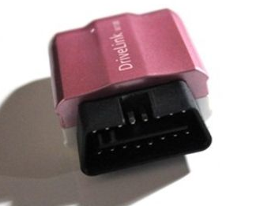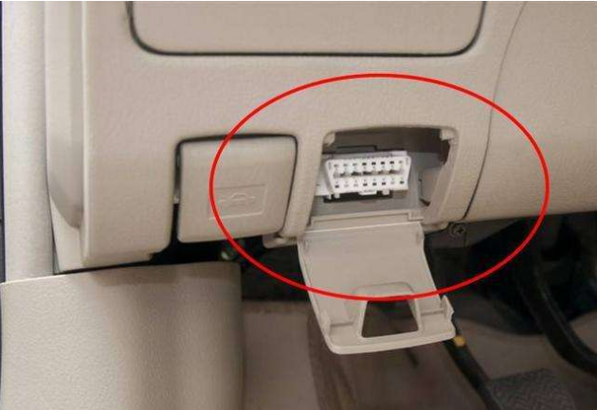

NO.1 Obtaining Fault Code Data [2018]

interface name  request method  Example of a request | getCurCodeV3
 | HTTP GET
 | http://api.18gps.net//GetDateServices.asmx/GetDate?method=getCurCodeV3&macid=601602230004&mds= cb445c3a41d940f69aa5c636d0cf2274
parameters | typology | mandatory field | descriptive
method | String | be | function call
mds | String | be | token
macid | String | be | device number
R&D Remarks
When data is an empty array "[]", it means that no fault code is detected.
Requested results
Success:
{
"success": "true",
"errorCode": "200",
"errorDescribe": "",
"err": "",
"info": "",
"data": [
{
"sysId": "2", //No significance
"obdcode": "P0205", //fault code name
"obdcodestr": "P0205", //fault code name
"obddescription": "Injector circuit/open circuit-cylinder 5", //trouble code translation
"obddescription_en": ""
}, }
{
"sysId": "0",
"obdcode": "P0308".
"obdcodestr": "P0308".
"obddescription": "Misfire detected on cylinder 8".
"obddescription_en": ""
}
],
"obdSys": [
{
"sysId": "0", //No significance
"obdTitle": "Ignition System", //which system it belongs to (16 system titles at the bottom)
"obdCount": 1 // How many fault codes are there in this system
}, }
{
"sysId": "1",
"obdTitle": "Body computer control system",
"obdCount": 0
}, }
{
"sysId": "2".
"obdTitle": "Fuel and Air Detection Systems".
"obdCount": 1
}, }
{
"sysId": "3".
"obdTitle": "Exhaust gas control system",
"obdCount": 0
}, }
{
"sysId": "4".
"obdTitle": "Gearbox control system".
"obdCount": 0
}, }
{
"sysId": "5".
"obdTitle": "Fuel and Air Detection Systems".
"obdCount": 0
}, }
{
"sysId": "6".
"obdTitle": "Vehicle Speed Idle Control System".
"obdCount": 0
}, }
{
"sysId": "7".
"obdTitle": "Computerized control systems".
"obdCount": 0
}, }
{
"sysId": "8".
"obdTitle": "Network Systems".
"obdCount": 0
}, }
{
"sysId": "9".
"obdTitle": "Chassis computerized control system",
"obdCount": 0
}, }
{
"sysId": "10".
"obdTitle": "Other Systems",
"obdCount": 0
}
],
"fraction": 80
}

The fault code system is divided into 16 categories:
Body Systems
Chassis systems
Fuel Air or Emission Control
Fuel or air
ignition system
emission control
Speed and Idle Control
Computer or auxiliary output circuits
transmission
hybrid power system
Powertrain Systems
auxiliary input
Computer or auxiliary output
Cylinder stop
network communication system
Other Systems

NO.2 Access to the latest vehicle condition data [2018]

interface name  request method  Example of a request | OBDLatestCarCondition
 | HTTP GET
 | http://api.18gps.net//GetDateServices.asmx/GetDate?method=OBDLatestCarCondition&macid=601804250020&mds= c8837ff880e4453ca2b168041b64e46d
parameters | typology | mandatory field | descriptive
method | String | be | function call
mds | String | be | token
macid | String | be | device number
R&D Remarks
None.
Requested results
Success:
{
"success": "true",
"errorCode": "200",
"errorDescribe": "",
"data": [{
"Number": "P_01",
"Key": "Speed".
"Value": "0 km/h"
}, {
"Number": "P_02",
"Key": "Engine RPM".
"Value": "601 rpm"
}, {
"Number": "P_03",
"Key": "Engine Coolant Temperature".
"Value": "74 °C"
}, {
"Number": "P_10",
"Key": "Calculated value of engine load".
"Value": "16 %"
}, {
"Number": "P_13",
"Key": "Instantaneous fuel consumption".
"Value": "100 L/100km"
}, {
"Number": "P_18",
"Key": "Control Module Voltage".
"Value": "27 V"
}, {
"Number": "P_19",
"Key": "Absolute position of gas pedal D".
"Value": "0 %"
}, {
"Number": "P_21".
"Key": "Brake Status".
"Value": "Brake inactivity"
}, {
"Number": "P_23",
"Key": "Instantaneous fuel consumption".
"Value": "2 L/h"
}, {
"Number": "P_26",
"Key": "OBD Module Status".
"Value": "On Trip"
}]
}

NO.3 Get Last Trip [2018] (Single)

interface name  request method  Example of a request | getStrokeData
 | HTTP GET
 | http://api.18gps.net//GetDateServices.asmx/GetDate?method=getStrokeData&mds=befcda89ec02489f9f6f76695a94cb3d&user_id= 20992b1f-315b-4920-b9a4-d3509f33a3c2
parameters | typology | mandatory field | descriptive
method | String | be | function call
mds | String | be | token
user_id | Guid | be | Device id
R&D Remarks
None.
Requested results
Success:
{
"id": "bd1382e2-af21-44b6-ba00-c2c62e49c3f3",
"btime": 1533254331000.
"etime": 1533263282000.
"distance": 46.42,
"maxspeed": 62.0,
"totalSpeedoverSeconds": null,
"brakeTimes": 0,
"emergencyBrakeTimes": 0,
"speedupTimes": 0,
"emergencySpeedupTimes": 0,
"speed": 18.
"maxTempc": 0.0,
"maxEngRPM": 1977,
"powerv": 0.0,
"totalfuelUsed": 18.737.
"fuelHKM": 0.0,
"overtimeDriverMinutes": 0,
"extend": [{
"Number": "T_01",
"Key": "Driving time".
"Value": "4934 s"
}, {
"Number": "T_03",
"Key": "Travel time".
"Value": "8951 s"
}, {
"Number": "T_08",
"Key": "ECU Total Mileage".
"Value": "4463300 km"
}, {
"Number": "T_15".
"Key": "Average RPM".
"Value": "88300 rpm"
}, {
"Number": "T_16".
"Key": "Average Throttle".
"Value": "1200 %"
}, {
"Number": "T_17",
"Key": "Load average".
"Value": "2500 %"
}, {
"Number": "T_21".
"Key": "Number of brakes".
"Value": "202 times"
}]
}

NO.4 Getting the itinerary
Interface name: getStrokeV3/getStrokeV3_extend
Request method: HTTP GET
Request Format:

[Example]
http://apitest.18gps.net//GetDateServices.asmx/GetDate?method=getStrokeV3&macid=xy1610100063&beginTime=1517129108109& endTime=1517129208109

Request Parameters:
parameters | typology | mandatory field | clarification
method | String | be | interface name
mds | String | be | token
macid | String | be | device number
beginTime | Long | be | Utc timestamp (start time)
endTime | Long | be | Utc time stamp (end time)
Interface Description:

Returns [JSON]:

Success:
{
"success": "true",
"errorCode": "200",
"errorDescribe": "",
"data": [{
"rows": [{
"totalfuelUsed": "0.5", //Total Fuel Consumption for Driving
"distance": "3.3", //distance traveled
"fuelHKM": "15.2",//100km fuel consumption
"totalSpeedoverSeconds": null,// speeding over time
"maxspeed": "61",//maximum number of times
"brakeTimes": 0,//dwell time
"emergencyBrakeTimes": 0,//Emergency Brake Times
"speedupTimes": 0,//high speedup times
"emergencySpeedupTimes": 0,// emergency speedup times
"speed": "0",//average vehicle speed
"maxTempc": 86,//maximum water temperature
"btime": "7:21",//start time
"etime": "7:34",//end time
"strokeTime": "2018/12/13",//date
"jsType": 2,//
"driveTime": 780.0,//drive time (sec)
"fraction": 100.0,//
"random": "95%", //
"coulometric": 0,//
"ExtendedData": {//extended data
"SpeedLimitFuel": 0,
"SpeedLimitMil": 0,
"SpeedLimitTime": 0,
"HighSpeedFuel": 0,
"HighSpeedMil": 0,
"HighSpeedTime": 0,
"MediumSpeedFuel": 0,
"MediumSpeedMil": 0,
"MediumSpeedTime": 0,
"LowSpeedFuel": 0,
"LowSpeedMil": 0,
"LowSpeedTime": 0,
"IdleSpeedFuel": 0,
"IdleSpeedTime": 0,
"SharpTurnCount": 0,
"SpeedLimitCount": 0,
"FastTrackCount": 0
}, }
"BeginTime": 1544656903000,//utc
"EndTime": 1544657683000//utc
}].
"avgFuel": "12.45",//This query average fuel consumption
"totalfuel": "2.9",//This query total fuel consumption
"totalmil": "23.3",//Total mileage for this query
"totalDriveTime": "6198",//Total drive time for this query (in seconds)
"totalCoulometric": "0",//.
"oilPrice": 0.0//.
}]
}
Failure:
{

}

NO.5 Batch Get Itinerary "Support Single" D platform support
Interface name: BatchGetTrips
Request method: HTTP GET
Request Format:

[Example]
http://apitest.18gps.net//GetDateServices.asmx/GetDate?method=BatchGetTrips&macids=xy1610100063,601603080472&beginTime= 1519780593918&endTime=1519803593918&mds=268cf32b992e4504b8d4f692446afe82
Request Parameters:
parameters | typology | mandatory field | instructions
method | String | be | interface name
mds | String | be | token
macids | String[] | be | Device List
beginTime | Long | be | Utc timestamp (start time)
endTime | Long | be | Utc time stamp (end time)
Interface Description:

Returns [JSON]:
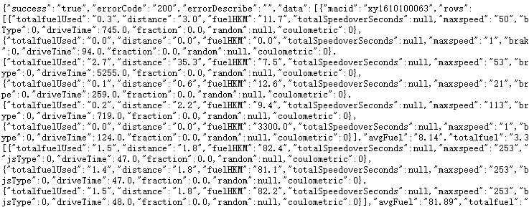

{
"totalfuelUsed": "0.3", //total fuel consumption
"distance": "3.0", //distance (km)
"fuelHKM": "11.7", //100km fuel consumption
"totalSpeedoverSeconds": null, // speeding over seconds
"maxspeed": "50", //maximum speed
"brakeTimes": 0, //dwell time (in seconds)
"emergencyBrakeTimes": 1, //Emergency Brake Times
"speedupTimes": 0, //Speedup Times (in seconds)
"emergencySpeedupTimes": 0, //emergency speedup times
"speed": "14", //average speed
"maxTempc": 68, //maximum water temperature
"maxEngRPM": 1500, //maxEngRPM
"powerv": 14.2, //voltage
"overtimeDriverMinutes": 1500, //fatigued driving (seconds)
"btime": "10:49:25", //start time
"etime": "11:02:23", //end time
"strokeTime": "2018/2/28", //date
"jsType": 0, //0: hasty 1: standard 2: steady 3: slow goat
"driveTime": 745.0, //total seconds driven
"fraction": 0.0,
"random": null,
"coulometric": 0
}, }

Success:
{
}
Failure:
{

}

Section III of the FAQs, the PC terminal

0. Description
Web-side for the operator's own platform, their own server to build the front-end page to supply user access, does not support the use of 18gps platform.

1. Add new users (including permissions)
interface name  request method  Example of a request | registerCustomer
 | HTTP GET
 | http://apitest.18gps.net/GetDateServices.asmx/GetDate?method=registerCustomer&mds=368867d0b6cc49af8e2685ff471e4cf2&name=上海 KU&schoolID=754a5a28-8f24-47ff-908f-c363663ab225&loginName=skd&pwd=123456&repwd=123456&grade=2&contact=& amp;phone=&addr=
parameters | typology | mandatory field | descriptive
method | String | be | interface name
mds | String | be | token
schoolID | Guid | be | Parent unit id
name | String | be | Client Name/Unit Name
loginName | String | be | Log in to your account
pwd | String | be | cryptographic
repwd | String | be | Confirm Password
grade | Int | be | Client Type
contact | String | clogged | associates
phone | String | clogged | telephones
addr | String | clogged | address
R&D Remarks
Here must pay attention to the grade this customer type this parameter, its value is not a unified standard, you need to query the server database, such as the need to use to the business department please consult.

Requested results
Success:
{
"id": "cfd2722a-4db6-47ab-974e-d0b6d30a7ecd",//guid assigned to the new account
"result": 1, //0 for failure
"success": true//true for success
}

2. Delete users
interface name  request method  Example of a request | deleteEnterprise
 | HTTP GET
 | http://apitest.18gps.net/GetDateServices.asmx/GetDate?method=deleteEnterprise&mds=368867d0b6cc49af8e2685ff471e4cf2&id= cfd2722a-4db6-47ab-974e-d0b6d30a7ecd
parameters | typology | mandatory field | descriptive
method | String | be | interface name
mds | String | be | token
id | Guid | be | Unit id
R&D Remarks
You cannot delete in the following 2 cases: the user device list is not empty, and other users exist at the user subordinate level.
Requested results
Success:
{
"success": "true",
"status": 1
}
Failure:
{
"success": "false",
"errorCode": "500",
"errorDescribe": "Failed to set an object reference to an instance of an object." ,// Can't find this user
"data": []
}

2. Get user list
interface name  request method  Example of a request | GetCustomTreeById
 | HTTP GET
 | http://apitest.18gps.net/GetDateServices.asmx/GetDate?method=GetCustomTreeById&mds=31532675bc4841ceacf0b1c2ed874946&id= e9c939f1-9c06-4312-b295-47f0162b4176
parameters | typology | mandatory field | descriptive
method | String | be | interface name
mds | String | be | token
id | Guid | be | Unit id
R&D Remarks
None.
Requested results
Success:
{
"success": "true",
"errorCode": "200",
"errorDescribe": "",
"data": [{
"id": "3dfca267-77e5-4933-8a72-e03e1c354d65", //Subordinate unit ids
"deptName": "A Thousand Times I Looked Back Without Smiling (2/2)",//client name/unit name
"deviceCount": 2, //total number of devices
"userName": "baidu",//login account
"pId": "e9c939f1-9c06-4312-b295-47f0162b4176", //parent id
"isParent": 0 // whether it is a parent node, 0 is not (means there are no more subordinates)
}, {
"id": "7ba648da-ad90-4a34-8788-822bcf666665",.
"deptName": "Tyumen Hill (0/0)",
"deviceCount": 0,
"userName": "qiuqiu",
"pId": "e9c939f1-9c06-4312-b295-47f0162b4176",
"isParent": 0
}, {
"id": "a615be7b-4f73-4267-a686-6ad5902e6ac3",
"deptName": "watch(1/1)",
"deviceCount": 1,
"userName": "shoubiao",
"pId": "e9c939f1-9c06-4312-b295-47f0162b4176",
"isParent": 0
}]
}

3. Access to user information
interface name  request method  Example of a request | getEnterpriseByID
 | HTTP GET
 | http://apitest.18gps.net/GetDateServices.asmx/GetDate?method=getEnterpriseByID&id=cfd2722a-4db6-47ab-974e-d0b6d30a7ecd&mds =368867d0b6cc49af8e2685ff471e4cf2
parameters | typology | mandatory field | descriptive
method | String | be | interface name
mds | String | be | token
id | Guid | be | Unit id
R&D Remarks
None.
Requested results
Success:
{
"success": "true",
"errorCode": "200",
"errorDescribe": "",
"data": [{
"id": "cfd2722a-4db6-47ab-974e-d0b6d30a7ecd",
"name": "Shanghai University of Science and Technology".
"phone": null,
"addr": null,
"contact": null, //contacts
"loginName": "skd", //login number
"company": "Shanghai Science and Technology University", //client name/unit name
"state": "",
"area": "",
"permission": 2, //tree level
"grade": 2, //account type
"artificial_person": "skd".
"office_tel": null,
"office_phone": null,
"credit_grade": "0", //none
"status": false, //whether to receive subordinate alarms
"balance": 0.0, //none
"helpTel": "", //none
"alarmSound": false //turn on alarm sound
}]
}

4. Modify user information
interface name  request method  Example of a request | modifyEnterprise
 | HTTP GET
 | http://apitest.18gps.net/GetDateServices.asmx/GetDate?method=modifyEnterprise&id=cfd2722a-4db6-47ab-974e-d0b6d30a7ecd&mds= 368867d0b6cc49af8e2685ff471e4cf2&company=Beijing University of Science and Technology&loginName=skd&grade=2&contact=&phone=&addr=
parameters | typology | mandatory field | descriptive
method | String | be | interface name
mds | String | be | token
id | Guid | be | Unit id
loginName | String | be | Log in to your account
grade | String | be | Client Type
contact | String | clogged | associates
phone | String | clogged | telephones
addr | String | clogged | address
company | String | clogged | Client Name/Unit Name
status | Int | clogged | Acceptance of subordinate alarms
R&D Remarks
Note: loginName represents the unit name when registering, while in this interface it represents the login account.
Requested results
Success:
{
"success": true
}

5. Reset user password
interface name  request method  Example of a request | resetCustomerPWD
 | HTTP GET
 | http://apitest.18gps.net/GetDateServices.asmx/GetDate?method=resetCustomerPWD&mds=368867d0b6cc49af8e2685ff471e4cf2&school_ id=cfd2722a-4db6-47ab-974e-d0b6d30a7ecd
parameters | typology | mandatory field | descriptive
method | String | be | interface name
mds | String | be | token
school_id | Guid | be | Unit id
R&D Remarks
There is permission validation here, and the interface is invalid if school_id is not managed by the token.
Requested results
Success:
{
"success": true,
"Pwd": "123456"
}

Add devices in bulk
interface name  request method  Example of a request | importIMEI
 | HTTP
 | http://apitest.18gps.net/GetDateServices.asmx/GetDate?method=importIMEI&mds=8b12225ee675411ba2f01a519c7d1d7c&macidsandsims =1990041401,;1990041402,;1990041403,&remark=&objectID=9d6ec2fe-a531-49e9-ac92-8a173c2fe428&product_type=218HY
parameters | typology | mandatory field | descriptive
method | String | be | interface name
mds | String | be | token
objectID | Guid | be | Unit id
product_type | String | be | Equipment Model
macidsandsims | String | be | Device number string [device-number,sim-card;device-number,sim-card;]
remark | String | clogged | Service Provider Description
R&D Remarks
Three points:
- Interface permissions are verified and users without add device permissions cannot be added.
- Post request.
- The device number string format must be punctuated in the English state.
The method of obtaining the model number is attached.
Requested results
Success:
{
"success": true,
"interance": [], //failure list
"result": [{ // list of successes
"sim_id": "1990041401"
}, {
"sim_id": "1990041402"
}, {
"sim_id": "1990041403"
}].
"num": 3, //number of successes
"balance": 0, //price
"errorCode": null, // error description
"OrderId": null //order number
}

Example of a request | http://apitest.18gps.net//GetDateServices.asmx/GetDate?method=getUserTypes&mds=c3769e91764d4e10b2a7be75e9e4954d
parameters | typology | mandatory field | descriptive
method | String | be | interface name
mds | String | be | token
Requested results
Success:
{
"success": "true",
"errorCode": "200",
"errorDescribe": "",
"data": [{
"Id": "218HY", //The model number is this field
"name": "218HY".
"WeightNumber": 0,
"MilNumber": 0,
"OilNumber": 1,
"LatlngNumber": 0,
"TempcNumber": 1,
"BetteryVNumber": 0,
"GpsCountNumber": 0,
"PowerVNumber": 0,
"GsmLevelNumber": 0,
"Door": 0.
"Acc": 1,
"Sim": 0,
"Guard": 0,
"OilElec": 1.
"Charger": 0,
"MacType": 17.
"Clockwise": 1,
"Vehicle": 0,
"Lockcnt": 0,
"TimeZone": 0,
"HeightNumber": 0,
"IsOBDDevice": 0,
"Describe": "ok",
"Stroke": 0.
"Photo": 0,
"Cmd": 1.
"Money": 1.
"SignalType": 0,
"MacTypeId": "XY318".
"SaveWifiData": false,
"SaveLbsData": false,
"CanFilter": true,
"CanExplainLBS": 0,
"CanSaveHisState": 0,
"Rental": false,
"Video": 0,
"Pressure": 0
}]
}

7. Access to equipment information (full)
interface name  request method  Example of a request | loadUser
 | HTTP GET
 | http://apitest.18gps.net/GetDateServices.asmx/GetDate?method=loadUser&user_id=e9acf370-9cb7-4d38-9089-97a96f4ad040&mds= 8b12225ee675411ba2f01a519c7d1d7c
parameters | typology | mandatory field | descriptive
method | String | be | interface name
mds | String | be | token
user_id | Guid | be | Device id
R&D Remarks
None.
Requested results
Success:
{
"success": "true",
"errorCode": "200",
"errorDescribe": "",
"data": [{
"user_name": "Emma", //device name
"sys_time": "2015/09/23 11:45:27", //last positioning time
"datetime": "2015/10/26 16:33:48", //last location update time
"heart_time": "2015/10/26 16:33:48", //last signal time
"sudu": 0.0, //overdrive setting value
"status": "", //none
"create_time": "2058/04/21", //platform expiration time
"remark": "", // Remarks
"use_time": "2014/11/29", // activation time
"factory_date": "2014/11/28", //factory time
"tel": " ", //telephone number
"sex": "粤B96853", //vehicle license plate number
"sim_id": "049021604295", //device number
"phone": "185794666", //sim card
"user_id": "e9acf370-9cb7-4d38-9089-97a96f4ad040",
"grade": 0, //none
"sale_type": 0, //none
"service_flag": "", //none
"product_type": "XY218C", //model number
"iconType": "01", //icon serial number
"out_time": "2058/04/21", //user expiration time
"jingdu": 114.035221666667, //longitude
"weidu": 22.6485566666667, //latitude
"su": null, //iccid
"owner": " ", //contacts
"jingwei": "114.035221666667;22.648556666666667",
"alarm": 0, //offline alarm switch, 0 off
"deviceRemark": " ", //service provider description
"alarmFuel": "", //none
"fuelPerHKM": "", //none
"fuelSize": "", //none
"maxFuelV": "", //none
"minFuelV": "", //none
"macVersion": null, //device software version number
"FuelTotalHeight": "", //none
"carColor": "", //none
"VideoConfig": null, //video address
"HighTempAlarm": 0.0, //high temperature alarm value
"LowTempAlarm": 0.0, //Low Temperature Alarm Value
"VendorCode": "", //vendor code
"OwnerId": "", // Owner ID
"PColour": 0, //plate color
"TerminalType": "", //Terminal Type
"DeviceCode": "" //device code
}]
}

8.1 [Account Login] Modification of equipment information (all)
interface name  request method  Example of a request | modifyUser
 | HTTP
 | http://apitest.18gps.net/GetDateServices.asmx/GetDate?method=modifyUser&mds=77915529595c4b438c9759d23f11490d&info=2
parameters | typology | mandatory field | descriptive
method | String | be | interface name
mds | String | be | token
user_id | Guid | be | Device id
info | Int | be | Modification type [2 authorized to modify user expiration, 1 not authorized]
sex | String | clogged | license plate number
user_name | String | clogged | Equipment Name
remark | String | clogged | note
owner | String | clogged | associates
tel | String | clogged | contact number
phone | String | clogged | sim card
out_time | String | clogged | User expiration time
alarm | Int | clogged | Offline alarm switch [0 off 1 on]
sudu | Double | clogged | Overspeed setting value
iconType | String | clogged | Icon serial number
HighTempAlarm | Double | clogged | High temperature alarm value
LowTempAlarm | Double | clogged | Low temperature alarm value
R&D Remarks
None.
Requested results
Success:
{
"success": true
}

8.2 [Equipment Login] Modify equipment information (all)
interface name  request method  Example of a request | modifyUser
 | HTTP
 | http://apitest.18gps.net/GetDateServices.asmx/GetDate?method=modifyUser&mds=77915529595c4b438c9759d23f11490d&info=3
parameters | typology | mandatory field | descriptive
method | String | be | interface name
mds | String | be | token
user_id | Guid | be | Device id
info | Int | be | Modification type [3]
sex | String | clogged | license plate number
user_name | String | clogged | Equipment Name
remark | String | clogged | note
owner | String | clogged | associates
tel | String | clogged | contact number
phone | String | clogged | sim card
alarm | Int | clogged | Offline alarm switch [0 off 1 on]
sudu | Double | clogged | Overspeed setting value
iconType | String | clogged | Icon serial number
HighTempAlarm | Double | clogged | High temperature alarm value
LowTempAlarm | Double | clogged | Low temperature alarm value
R&D Remarks
Compare the difference between account login modifications:
1. The value of info is different, the value is fixed 3;
2. The modifications are different.
Requested results
Success:
{
"success": true
}

9. Reset device password
interface name  request method  Example of a request | resetUserPWD
 | HTTP GET
 | http://apitest.18gps.net/GetDateServices.asmx/GetDate?method=resetUserPWD&user_id=9235223f-4907-4904-bbbc-c92110321541&mds =31532675bc4841ceacf0b1c2ed874946
parameters | typology | mandatory field | descriptive
method | String | be | interface name
mds | String | be | token
user_id | Guid | be | Device id
R&D Remarks
There is permission validation here, if user_id is not in the token's administrative scope then the interface is invalid.
Requested results
Success:
{
"success": true,
"pwd": "123456"
}

10. Bulk transfer of equipment
interface name  request method  Example of a request | moveUser
 | HTTP
http://apitest.18gps.net/GetDateServices.asmx/GetDate?
method=moveUser&cust_id=d7bab2a7-dc43-4546-b9f4-e1bd8d37d774&sim_ids=358740056033425,456456456&mds= 77915529595c4b438c9759d23f11490d
parameters | typology | mandatory field | descriptive
method | String | be | interface name
mds | String | be | token
cust_id | Guid | be | Unit id (to whom transferred)
sim_ids | String | be | Device Number String [Device No., Device No., Device No.]
R&D Remarks
None.
Requested results
Success:
{
"success": true,
"num": 2, //number of successes
"result": [{ // list of successes
"sim_id": "358740056033425"
}, {
"sim_id": "456456456"
}].
"interance": [] // list of failures
}

11. Batch delete devices
interface name  request method  Example of a request | batchDeleteProduct
 | HTTP
 | http://apitest.18gps.net/GetDateServices.asmx/GetDate?method=batchDeleteProduct&logn_id=754a5a28-8f24-47ff-908f-c363663ab225& amp;sim_ids=067045065689,358740056031254&custid=e9c939f1-9c06-4312-b295-47f0162b4176&mds=77915529595c4b438c9759d23f11490d
parameters | typology | mandatory field | descriptive
method | String | be | interface name
mds | String | be | token
logn_id | Guid | be | Unit id [logged in by]
custid | Guid | be | Unit id [user being operated on, can be self]
sim_ids | String | be | Device Number String [Device No., Device No., Device No.]
R&D Remarks
None.
Requested results
Success:
{
"success": "true"
}

12. Get device albums
interface name  request method  Example of a request | GetPictureList
 | HTTP GET
 | http://apitest.18gps.net//GetDateServices.asmx/GetDate?&method=GetPictureList&macid=078561000561&Count=15&MinTime= 1531535062243&mds=7cace7a6f275496ba5065336c1a16bb2
parameters | typology | mandatory field | descriptive
method | String | be | interface name
mds | String | be | token
macid | Guid | be | device number
MinTime | Long | be | Utc timestamp in milliseconds (to control the range of acquisition)
Count | Int | be | How many images to get
R&D Remarks
Show more practices?
The first time you get the minTime set to tomorrow, if there are 10, that is, there are still behind, the design of a drop-down or more buttons, just add 10 pictures in the time the smallest one assigned to the minTime to continue to call this interface will be able to get more, and so on to get all the pictures.
Requested results
Success:
{
"success": "true",
"errorCode": "200",
"errorDescribe": "",
"data": [{
"Id": "08ded06e-6b4c-4b3f-a8fd-b94ac36283f0",.
"Macid": "078561000561".
"PicName": "http://vipapi.18gps.net/GetDateServices.asmx/GetDate?method=DownLoadPicOrVideo&fileName=078561000561_ 201802020855539804.jpg&mds=7cace7a6f275496ba5065336c1a16bb2",
"Addtime": "2018/02/02 16:55:55",
"Lat": 22.701765.
"Lon": 113.821802.
"Time": 1517561755295
}, {
"Id": "305bf138-05e1-4a42-a2e6-75fcdb473cb6",.
"Macid": "078561000561".
"PicName": "http://vipapi.18gps.net/GetDateServices.asmx/GetDate?method=DownLoadPicOrVideo&fileName=078561000561_ 201802020855336913.jpg&mds=7cace7a6f275496ba5065336c1a16bb2",
"Addtime": "2018/02/02 16:55:35",
"Lat": 22.701765.
"Lon": 113.821802.
"Time": 1517561735001
}, {
"Id": "fc64de3d-7a48-4033-9874-b9ba409585e5",.
"Macid": "078561000561".
"PicName": "http://vipapi.18gps.net/GetDateServices.asmx/GetDate?method=DownLoadPicOrVideo&fileName=078561000561_ 201802020855096289.jpg&mds=7cace7a6f275496ba5065336c1a16bb2",
"Addtime": "2018/02/02 16:55:11",
"Lat": 22.701765.
"Lon": 113.821802.
"Time": 1517561711460
}, {
"Id": "94219176-fd25-4a4b-b686-56f5406ed75c",.
"Macid": "078561000561".
"PicName": "http://vipapi.18gps.net/GetDateServices.asmx/GetDate?method=DownLoadPicOrVideo&fileName=078561000561_ 201802020854248323.jpg&mds=7cace7a6f275496ba5065336c1a16bb2",
"Addtime": "2018/02/02 16:54:27",
"Lat": 22.701765.
"Lon": 113.821802.
"Time": 1517561667196
}]
}

13. Get device video
interface name  request method  Example of a request | GetVideoList
 | HTTP GET
 | http://apitest.18gps.net//GetDateServices.asmx/GetDate?&method=GetVideoList&macid=078561000561&Count=10&MinTime= 1531535094212mds=7cace7a6f275496ba5065336c1a16bb2
parameters | typology | mandatory field | descriptive
method | String | be | interface name
mds | String | be | token
macid | Guid | be | device number
MinTime | Long | be | Utc timestamp in milliseconds (to control the range of acquisition)
Count | Int | be | How many images to get
R&D Remarks
None.
Requested results
Success:
{
"success": "true",
"errorCode": "200",
"errorDescribe": "",
"data": [{
"Id": "413ac1cc-5796-4c53-9bf1-1574049c602c",.
"Macid": "078561000561".
"VideoName": "http://vipapi.18gps.net/GetDateServices.asmx/GetDate?method=DownLoadPicOrVideo&video=078561000561_ 201802020856222301.mp4&mds=7cace7a6f275496ba5065336c1a16bb2",
"Addtime": "2018/02/02 16:56:25",
"Lat": 22.701765.
"Lon": 113.821802.
"Time": 1517561785131
}, {
"Id": "4266c302-f49b-47a8-881b-3a1c616201fc",.
"Macid": "078561000561".
"VideoName": "http://vipapi.18gps.net/GetDateServices.asmx/GetDate?method=DownLoadPicOrVideo&video=078561000561_ 201802020854457805.mp4&mds=7cace7a6f275496ba5065336c1a16bb2",
"Addtime": "2018/02/02 16:54:48",
"Lat": 22.701765.
"Lon": 113.821802.
"Time": 1517561688710
}]
}

Section IV of the FAQs, WebApi web page version of the interface
This is the web version of the interface, provide the parameters to get the web page.
http://www.18gps.net/GetDataService.aspx?method=loginSystem&LoginName=nunu&LoginPassword=123456&LoginType=ENTERPRISE& amp;language=cn&ISMD5=0&timeZone=8&apply=APP&loginUrl=

1.Follow the car page
Interface name: Follow
Request method: HTTP GET
Request Format:

[Example]
http://www.18gps.net:8028/RouterPass.ashx?method=Follow&mds=2ae501b9a238468b9715e8c5a90fc476&custid=1a9b8748-ff05-450a- 9edd-9dfebbf0fbae&mapType=BAIDU&deviceid=7a01aa2e-0df2-43d7-8b03-2bea882f336b&deviceName=Kuo sir

Request Parameters:
parameters | typology | mandatory field | clarification
method | String | be | interface name
mds | String | be | token
custid | Guid | be | Unit id
mapType | String | be | Map type (BAIDU)
deviceid | Guid | be | Device id
deviceName | String | clogged | Equipment Name
Interface description: none.

2. Playback page
Interface name: Playback
Request method: HTTP GET
Request Format:

[Example]
http://www.18gps.net:8028/RouterPass.ashx?method=Playback&mds=2ae501b9a238468b9715e8c5a90fc476&custid=1a9b8748-ff05-450a- 9edd-9dfebbf0fbae&mapType=BAIDU&deviceid=7a01aa2e-0df2-43d7-8b03-2bea882f336b&deviceName=Kuo sir

Request Parameters:
parameters | typology | mandatory field | instructions
method | String | be | interface name
mds | String | be | token
custid | Guid | be | Unit id
mapType | String | be | Map type (BAIDU)
deviceid | Guid | be | Device id
deviceName | String | clogged | Equipment Name
Interface description: none.

Section V, Voided Records.

1. Acquisition of vehicle condition data [nullified]
Interface name: getCarHardWare/getVehicleData
Request method: HTTP GET
Request Format:

[Example]
http://apitest.18gps.net//GetDateServices.asmx/GetDate?&method=getCarHardWare&macid=xy1610100063&mds= 27643b87176b454492f45305924ef391

Request Parameters:
parameters | typology | mandatory field | clarification
method | String | be | interface name
macid | String | be | device number
mds | String | be | token
Interface Description: None

Returns [JSON]:
Success:
{
"success": "true",
"errorCode": 200,
"errorDescribe": "Fetching vehicle condition data was successful",
"obdList": [],
"obdcode": "healthscore".
"obdcodestr": "healthscore".
"obddescription": "100".
"rows": {
"macid": "xy1610100063",//device number
"P1": 0.0,//vehicle speed
"P2": 0.0,//engine speed
"P3": 0.0,// engine coolant temperature
"P4": 65.535,//air flow rate
"P5": 0.0,//air temperature
"P6": 0.0,//Inlet manifold absolute pressure
"P7": 0.0,// Long-term fuel correction
"P8": 0.0,// ambient temperature
"P9": 0.0,//mileage
"P10": 0.0,// load calculation value
"P11": 0.0,//throttle absolute position
"P12": 0.0,//cylinder 1 ignition advance angle
"P13": 0.0,//Instantaneous fuel consumption
"P14": 0.0,//accumulated fuel consumption
"P15": 0.0,// accelerator pedal D
"P16": 0.0,// accelerator pedal E
"P17": 0.0,// accelerator pedal F
"P18": 0.0,//control module voltage
"P47": 0.0,// Remaining oil volume
"speed": 0.0,//speed
"fraction": "100",//ratings
"StateTime": "2018/1/25 17:12:50",//car condition state time
"CurCodeTime": "2018/1/25 17:12:13",//last uploaded fault code time
"HisCodeTime": "2018/1/25 17:12:13"//this field [discarded]
}
}
Failure:
{

}

2. Get the fault code [void]
Interface name: getCurCodeV3
Request method: HTTP GET
Request Format:

[Example]
http://apitest.18gps.net//GetDateServices.asmx/GetDate?method=getCurCodeV3&macid=xy1610100063&mds= 27643b87176b454492f45305924ef391

Request Parameters:
parameters | typology | mandatory field | clarification
method | String | be | interface name
macid | String | be | device number
mds | String | be | token
Interface Description: None

Returns [JSON]:
Success:
{
"success": "true",
"errorCode": "200",
"errorDescribe": "",
"err": "",
"info": "",
"data": [],//fault code
"obdSys": [{
"sysId": "0",
"obdTitle": "Body Systems",//description
"obdCount": 0
}, {
"sysId": "1",
"obdTitle": "Chassis Systems".
"obdCount": 0
}].
"fraction": 100
}
Failure:
{

}

3. Account registration (please use account 11 to register new) [void]
interface name  request method  Example of a request | LXVehicleInfoRegister
 | HTTP GET
 | http://apitest.18gps.net//GetDateServices.asmx/GetDate?method=LXVehicleInfoRegister&username=15019466955&password=123456& amp;parentId=d99bf6240faf4cdd9771469db0db98c8
parameters | typology | mandatory field | descriptive
method | String | be | interface name
username | String | be | Registered Account/Mobile Phone Number
password | String | be | Register Password
parentId | Guid | be | Parent unit id (direct relationship)
R&D Remarks
The parameter parentId in the interface needs to specify a superior id to which all registered users belong to manage, and this id needs to be applied to the business department.

Error Code:
200 Successful registration
500 Registration failure
1001 Account number exists/phone number exists
1002 Parent unit does not exist, no parent id filled in
1005 Account or password cannot be empty
Requested results
Success:
{
"success": "true",
"errorCode": "200", //registration successful
"errorDescribe": "",
"data": []
}
Failure:
{
"success": "false",
"errorCode": "1001", //account number already exists/phone number already exists
"errorDescribe": "",
"data": []
}

